When create the category, that category should appear and show the add sub category
but it redirects the top of the page.

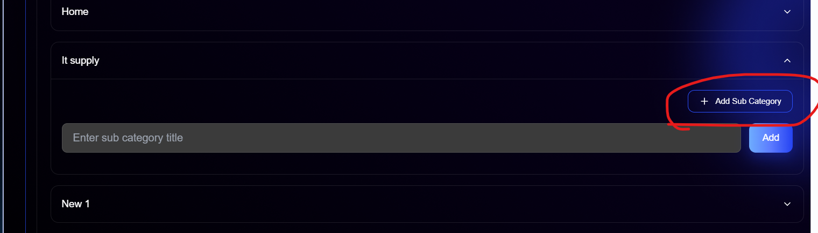
When click on this button, sub category field should be close

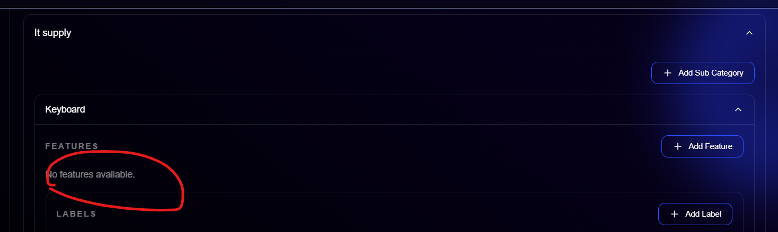
When updated the feature, it hides the feature.

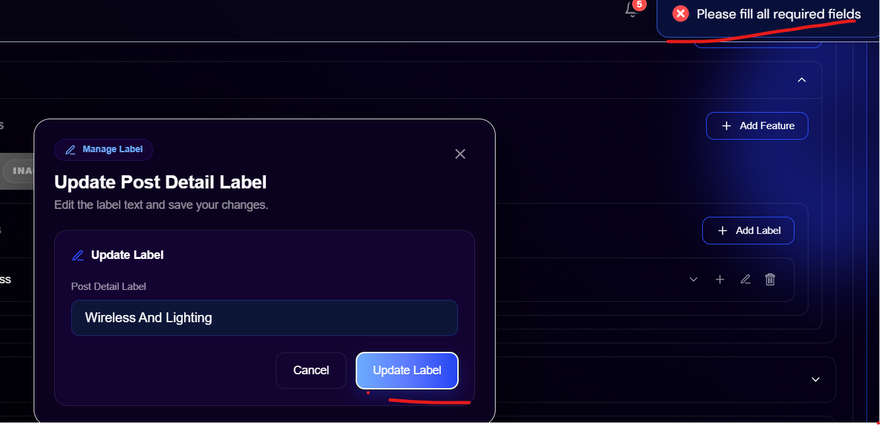
When updating the label
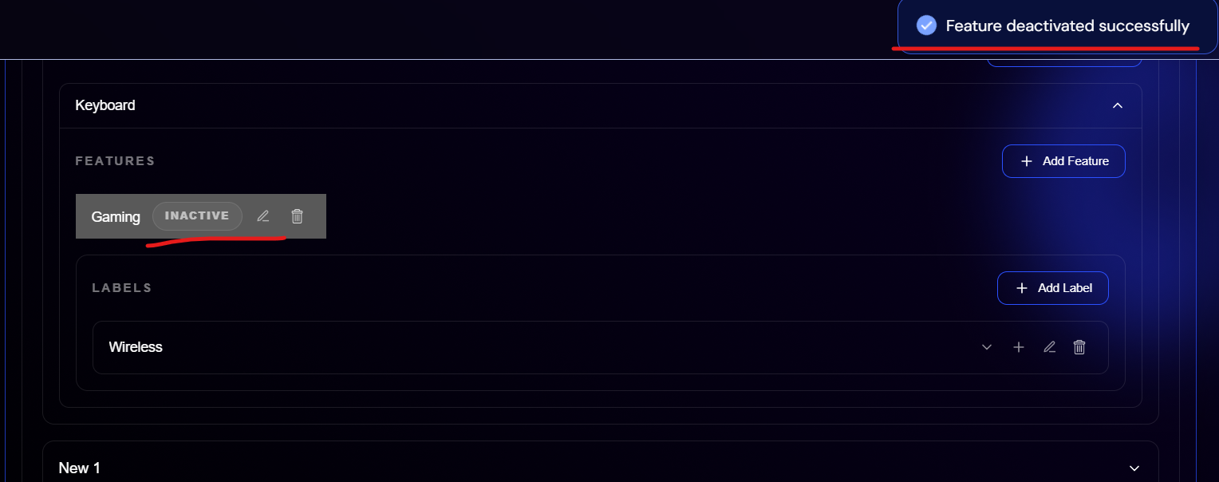
When inactive the feature, it shows the inactive popup but after refreshing the page it shows inactive
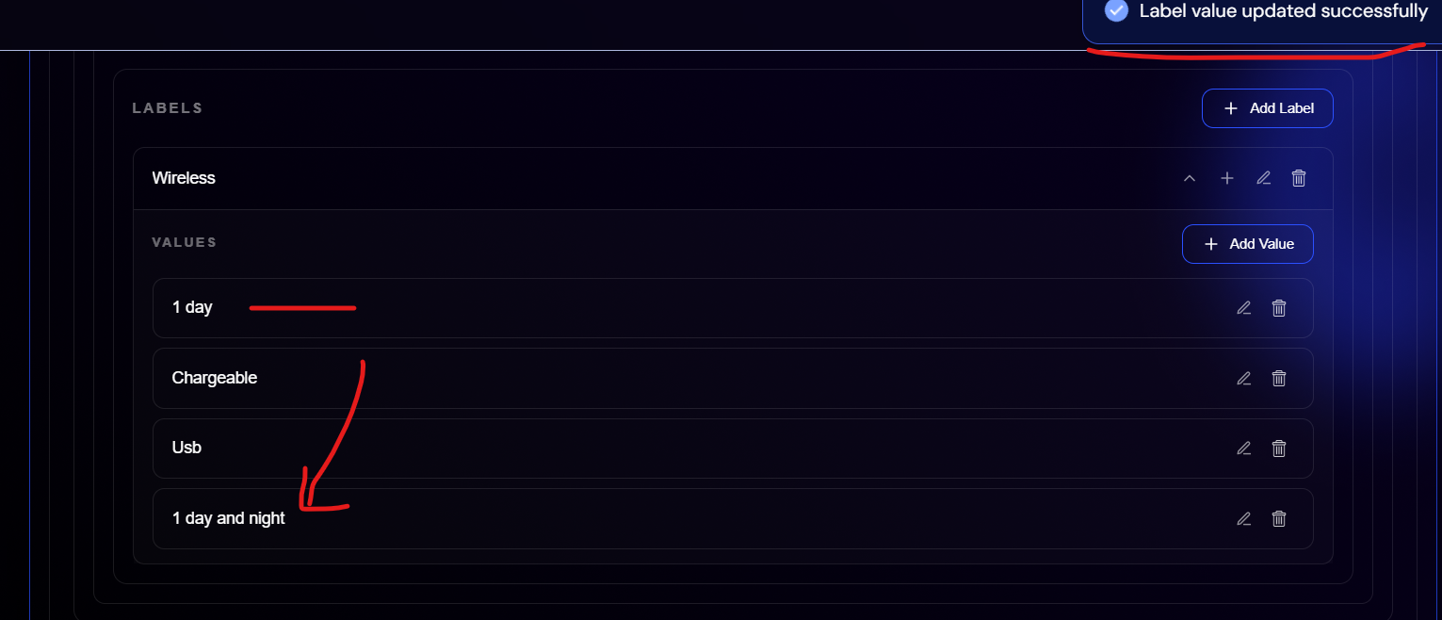
I updated the values of 1 day value, the popup also appears but it created the new value instead of updating the existing one.
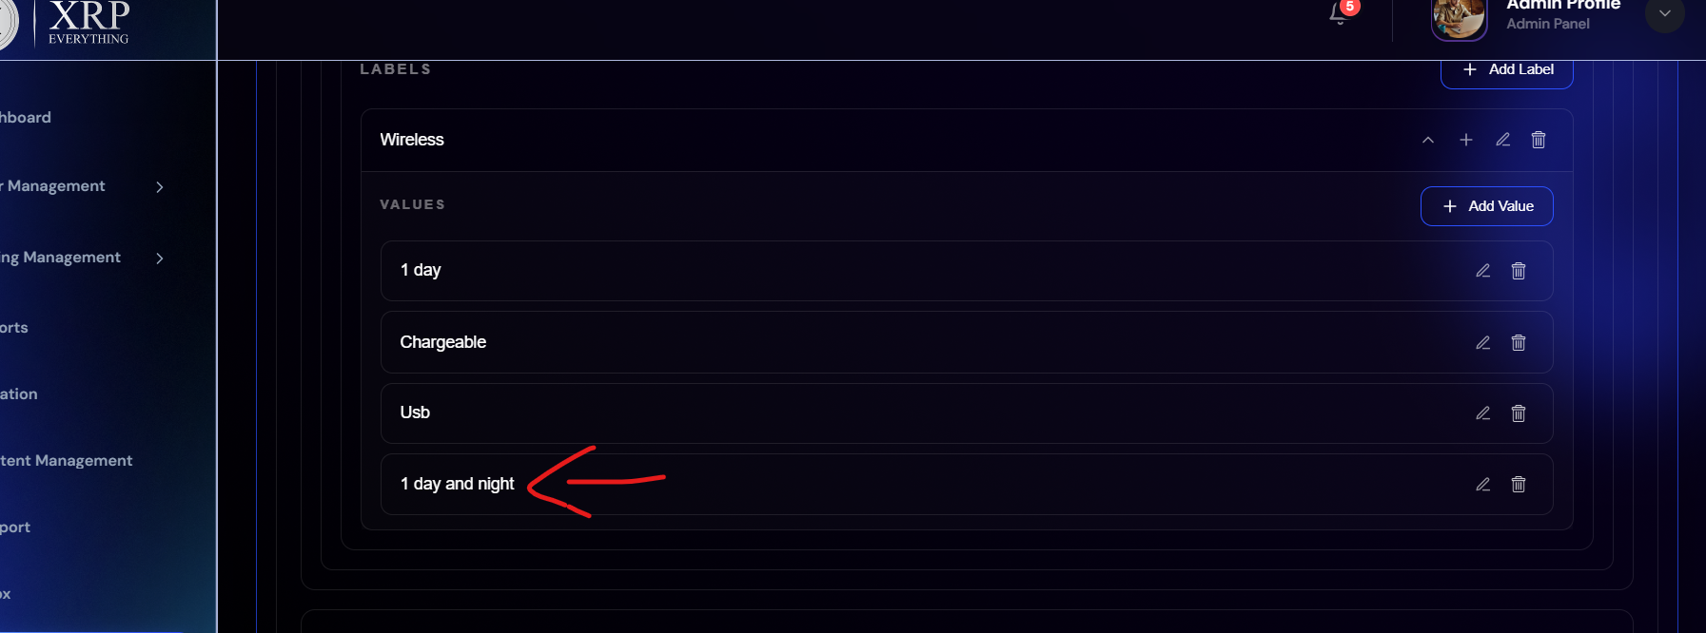
I deleted that value, popup also appears but after refreshing the page it still shows that value

